MS Project Tutorial

MS Project 2003 is a family of products designed to address the work and people management needs of any organization. Project 2003 suit of products include MS-Office Project Standard, MS-Office Project Professional, MS-Office Project Server, and MS-Office Project Web Access.

Project Professional is the desktop project management program that can be used with Project Server and Project Web Access to form the Enterprise Project Management (EPM) Solution.

Project Server is the flexible platform that supports the portfolio management, resource management, and collaboration capabilities in the EPM Solution. Project Server enables organizations to store project and resource information centrally and consistently.

Project Web Access is the Web portal that enables you to connect to the project and resource information that is stored in Project Server and collaborate on projects. Team members who need access to Project Server information but do not require the scheduling capabilities of Project Professional—can use Project Web Access through a Web browser to view and analyze information.

In this lab we would be learning to use only the “Project Professional”. “Project Server” and “Project web access” are not installed in the CIS servers.
Things that you should do/think about before
Before embarking on the project you need to put down a few key points very clearly -
- Conceptualize and identify the purpose of the project
- Define its objectives
- Finalize its scope
- Identify its activities
- Assign resources to activities
- Create an estimate of time and costs
- Make honest assumptions about various relevant factors that can affect the duration of a project and its costs
- Discuss alternative scenarios and build contingency plans
MS Project cannot help you with (1), (2), (7) and (8) but it can carry the remaining on its shoulders and sail you smoothly to your goals.

Terms that you need to know
Tasks: They are a division of all the work that needs to be completed in order to accomplish the project goals.
There are 4 major types of tasks:
- Summary tasks- They contain subtasks and their related properties.
- Subtasks- they are smaller tasks that are part of a summary task.
- Recurring tasks-are tasks that occur at regular intervals.
- Milestones-are like interim goals in the project. They are tasks that are set to zero duration.
Scope: of any project is a combination of all individual tasks and their goals.
Resources: can be people, equipment, materials or services that are needed to complete various tasks. The amount of resources affects the scope and time of any project.

Today’s lab

Things to do:
- Create Project
- Add Tasks and subtasks to a project
- Assign task duration
- Show progress of task (how much has been accomplished?)

Go to Start-> All Programs ->Microsoft Office Project 2003

- Create a Project

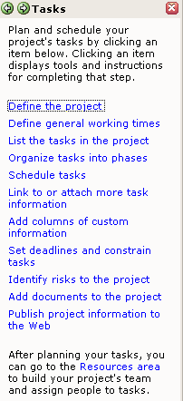
You should be able to see a ‘tasks’ list on the left as shown here. Click on “Define the project” link.

  - Give the start date of your project.
  - Click on “Save and go to Step2”
  - For Collaborate on your project, select “No” and go to Step 3.
  - Save and finish.

If you want to specify which days and hours you want the team to work, or which days are off/holidays then click on “Define general working time” and follow the 5 steps. In our case we might not want to do that.

Click on “List the tasks in the project”.

II) Add Tasks/Sub-Tasks to your project

- Click on the ‘Task Name’ Column and type out the task that you want to perform as part of the project.
- In the “Duration” column you should be able to specify the time taken in minutes. So, enter the number of minutes followed by “m”. You can enter task duration as and when you decide upon the suitable estimate. If you are not sure about how much time you need for a task, you can put a “?” for duration.
- Tasks that are milestones are marked “0” duration.

Adding Sub-Task
To add a sub-task, insert a row below the task for which you are adding a sub-task. For e.g. - if “Meeting” is a task, its sub task could be “Setting the agenda” for the meeting. Then insert a row below “Meeting”.

Add all the sub-tasks for the concerned task. Then select all the sub-task (you can select multiple sub tasks by holding down the ‘ctrl’ key).

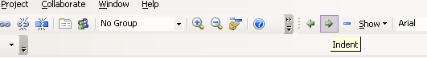

Click on the right arrow icon as shown above. This would indent the sub-tasks under the Task.

- Adding Resources
Double click on any tasks/sub-tasks and the ‘task information’ window pops up. Check on the ‘Resources’ tab and give the resource names (the name of the person who is assigned the task) and Click OK.
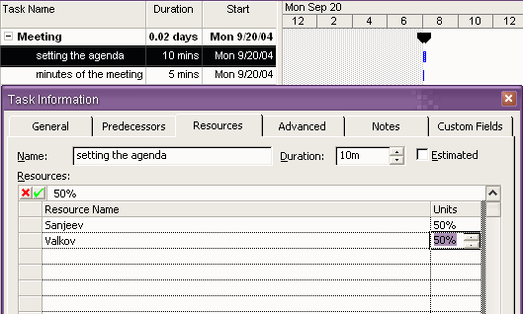

- Linking tasks:
Sometimes, even after designing a schedule many unforeseen changes can affect the completion of tasks midway. This could lead to disruption to completion of other related tasks. To solve this problem, MS Project allows you to link tasks in various ways. By linking tasks Project adjusts the schedule whenever there are changes that affect duration of other tasks.
A task that needs to be completed before are called predecessor task and the linked tasks is its successors.
Tasks can be linked in four ways: -
  - Finish-to-Start: Predecessor finishes and the other starts
  - Start-to-Finish: Task begins at the same time as its predecessor finishes.
  - Finish-to-Finish: Both tasks finish at the same time.
4. Start-to-Start: Start of the predecessor determines when the other starts. This is the default setting for any pair of tasks.
-Double click on any task to bring up the “task information” window. Select the “Predecessors” tab and select the predecessor for the task from the drop down list.
-Click on “Schedule Tasks” on the “Tasks” list in the left.
-Select the predecessor and the current task (multiple tasks are selected using ‘ctrl’) and click on the appropriate type of link that you want to provide, on the left.

- How much has been accomplished?
Double click on any task and bring up the “task information” window. In the “general” tab, you can specify the amount of work that has been completed. Also check out how the Gantt chart reflects the amount of work that has been completed.

Some Extra Notes
- You can add notes to each of your task. When you bring up the “task information” window for each task, you can click on the “notes” tab and add appropriate notes for the task. If you feel like giving a hyper link for each task, that would take you to the web-page that lists out more information, you can do that by-right click the mouse on each selected task and select “Hyperlink”. Add the hyperlink (URL), which you want to provide.
- You can set deadlines and constraints in the “task information” window. Select the “advanced” tab and select the constraints that you want to specify.
- If you want to view the Gantt chart more clearly, you can zoom on it. Right click on the calendar over the Gantt chart and click on zoom. You can specify the units in which the Gantt chart would display.

